Trailer Brake Mode Control Function – CGEA1.3/1.2/1.1

Functional Description

When the vehicle is equipped with a Trailer Brake Module (or Trailer Brake Controller, TBC) the Trailer Brake Mode control function allows the driver to toggle the status of the Trailer Brake Mode from Electric only to Electric Over Hydraulic (EOH). The Instrument Cluster uses the Trailer Brake Mode Actual signal for the Message Center function and the Trailer Brake Mode Request signal to toggle the Trailer Brake Mode in the TBM module. The driver can also select the TBC Effort (Low/Medium/High) vi the Setting Menu in the cluster. The Instrument Cluster uses the TrlBrkInitOut_D_Stat signal for the Message Center function and the TrlBrkInitOut_D_Rq signal to change the Trailer Brake Effort in the TBM module.

Interfaces

Interface Context Diagram (I/O Block Diagram)
Figure 1 Trailer Brake Mode Function Context Diagram
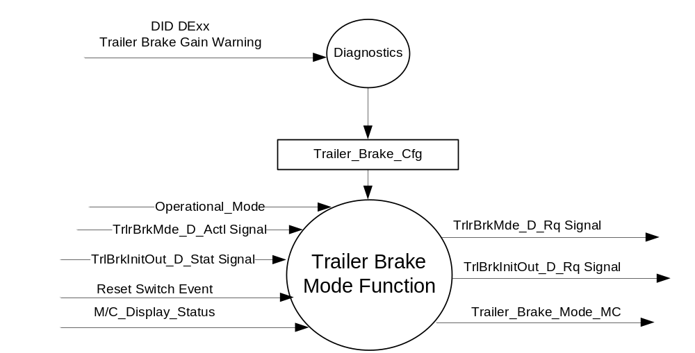

Inputs

- INTERNAL:
- Reset Switch Event
- TBC Trailer_Brake_Cfg
- Operational_Mode
- M/C_Display_Status
- MUX message on the CAN Bus from TBM

- TrlrBrkMde_D_Actl Signal
Signal Name | Size (bits) | Detail | Units | Res. | Offset | State Encoded | Min | Max
TrlrBrkMde_D_Actl | 1 |  | SED | 1 | 0 |  | 0  (0x0) | 1 (0x1)
 |  | Electric |  |  |  | (0x0)
 |  | Electric_Over_Hydraulic |  |  |  | (0x1)

- TrlBrkInitOut_D_Stat Signal
Signal Name | Size (bits) | Detail | Units | Res. | Offset | State Encoded | Min | Max
TrlBrkInitOut_D_Stat | 2 |  | SED | 1 | 0 |  | 0  (0x0) | 3 (0x3)
 |  | Null |  |  |  | (0x0)
 |  | Light |  |  |  | (0x1)
 |  | Medium |  |  |  | (0x2)
 |  | Heavy |  |  |  | (0x3)

Outputs
- Trailer_Brake_Mode_MC
- MUX message on the CAN Bus

- TrlrBrkMde_D_Rq Signal
Signal Name | Size (bits) | Detail | Units | Res. | Offset | State Encoded | Min | Max
TrlrBrkMde_D_Rq | 1 |  | SED | 1 | 0 |  | 0 (0x0) | 1 (0x1)
 |  | Electric |  |  |  | (0x0)
 |  | ElectricOverHydraulic |  |  |  | (0x1)

- TrlBrkInitOut_D_Stat Signal
Signal Name | Size (bits) | Detail | Units | Res. | Offset | State Encoded | Min | Max
TrlBrkInitOut_D_Rq | 2 |  | SED | 1 | 0 |  | 0  (0x0) | 3 (0x3)
 |  | Null |  |  |  | (0x0)
 |  | Light |  |  |  | (0x1)
 |  | Medium |  |  |  | (0x2)
 |  | Heavy |  |  |  | (0x3)

Function/Performance

Operational Modes

Mode | Differentiating Vehicle Conditions
Sleep Mode | Trailer Brake Mode Control Function Text Message Disabled
Limiting Mode | Trailer Brake Mode Control Function Text Message Disabled
Normal Mode | Trailer Brake Mode Control Function Text Message Enabled / Disabled
Crank Mode | Trailer Brake Mode Control Function Text Message Enabled / Disabled

Voltage Levels

Refer to the Cluster Features table located in the Operational Modes and Voltage Range Strategies section in this SPSS

Human-Machine Interface

Visual

Indicator Graphics / Display Format
For High End Display (SHMI), refer to “<Program> Cluster Menu Structure.xls”.
Example Graphics:
Menu level 1 | Menu level 2 |  | Menu level 3 | Conditions Required to Display
Trailer Brake | Mode | ● | Electric | Level 1 - Trailer_Brake_Cfg = 0x1
Trailer Brake | Mode | ❍ | EOH
Trailer Brake | Effort | ● | Light
Trailer Brake | Effort | ❍ | Medium
Trailer Brake | Effort | ❍ | Heavy

Refer to Message Center Function description reference "B Display 2x14 Text Message List.xls" file or "E Display 2x14 Text Message List.xls" file -- Message ID SU278 and SU920

Indicator Color Coordinates

Reference section COLOR & ILLUMINATION REQUIREMENTS (GRAPHICS)

Indicator Characteristics
Refer to Message Center X Display_Y Button Interface Section, where X and Y are appropriate values in this document.

Audio

None

Switch Control Logic

Consumer access to the Trailer Brake Mode Configuration shall be as specified in the message center basic functionality display as specified in Message Center X Display_Y Button Interface Section, where X and Y are appropriate values in this document.

System Accuracy

Within a 100msec of receiving a message that results in a change of state the cluster will update the display to the proper status.

Operation: Performance and Functional

Subsystem Algorithm Flowchart / State Diagram

Figure 2 Trailer Brake Mode Flowcharts

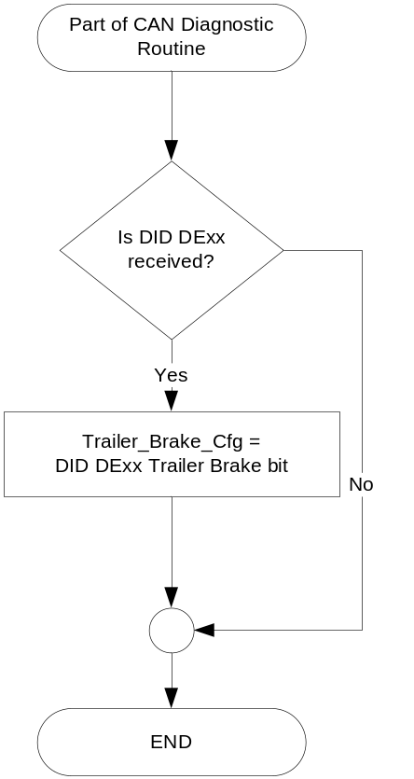

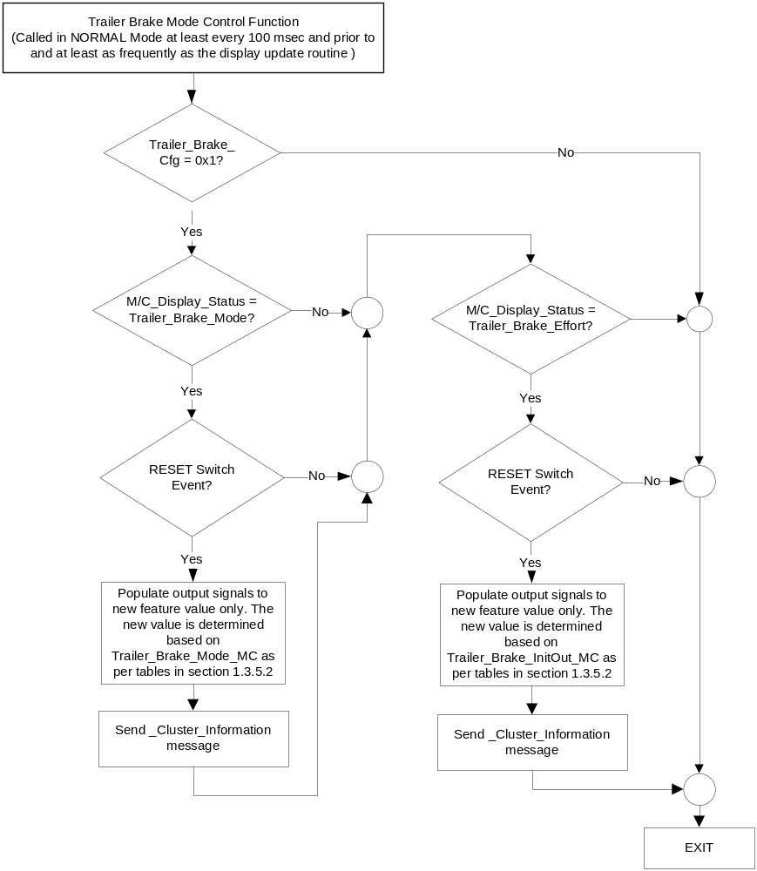

Note: In the Trailer Brake Mode Function Flowchart, the definition of "RESET Switch Event" is defined in Message Center X Display_Y Button Interface Section, where X and Y are appropriate values in this document.

- Trailer_Brake_Mode_MC State Assignment

TrlrBrkMde_D_Actl  HS_CAN Signal | Trailer_Brake_Mode_ MC
Electric (0x0) | Electric (0x0)
Electric_Over_Hydraulic (0x1) | EOH (0x1)
Missing per Section 1.4.1 | Error (0x2)

- Trailer_Brake_Mode_MC State Assignment
TrlBrkInitOut_D_Stat  HS_CAN Signal | Trailer_Brake_InitOut_ MC
Light (0x1) | Light (0x1)
Medium (0x2) | Medium (0x2)
Heavy (0x3) | Heavy (0x3)
Null (0x0) | Error (0x0)
Missing per Section 1.4.1 | Error (0x0)

Operation Description (supports algorithm flowchart /state diagram)

- Message Center Display per Current State for TBCM Mode
Trailer_Brake_Mode_MC | Message ID: SU278  Reset Switch Event | Next TrlrBrkMde_D_Rq State
EOH (0x1) | TBC MODE  ELECTRIC <EOH> | Electric (0x0)
Electric (0x0) | TBC MODE  <ELECTRIC> EOH | ElectricOverHydraulic (0x1)
Error (0x2) | TBC MODE  ELECTRIC EOH | ElectricOverHydraulic (0x1)

- High End Display and TBC Mode Request Messages

based upon Trailer_Brake_Mode_MC
Trailer_Brake_Mode_MC | Display Menu | 5-Button  Switch Selection Event | TrlBrkMde_D_Rq  Signal
Electric (0x0) | 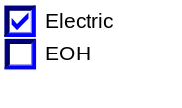 | Up/Down + OK (Select EOH) | 0x1 (ElectricOverHydraulic)
EOH (0x1) | 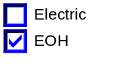 | Up/Down + OK (Select Electric) | 0x0 (Electric)
Error (0x2) | 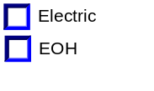 | Up/Down + OK (Select Electric or EOH) | 0x0 (if Electric is Selected)  0x1 (if EOH is Selected)
Note: Trailer_Brake_Cfg must be set to Enabled (0x1) to display this menu

- Message Center Display per Current State for TBCM Effort

Trailer_Brake_InitOut_ MC | Message ID: SU920  Reset Switch Event | Next TrlrBrkInitOut_D_Rq State
Light (0x1) | TBC EFFORT  <LOW> MED HIGH | Medium (0x2)
Medium (0x2) | TBC EFFORT  LOW <MED> HIGH | Heavy (0x3)
Heavy (0x3) | TBC EFFORT  LOW MED <HIGH> | Light (0x1)
Error (0x0) | TBC EFFORT  LOW MED HIGH | Light (0x1)

- High End Display and TBC Mode Request Messages

based upon Trailer_Brake_InitOut_MC

Trailer_Brake_InitOut_MC | Display Menu | 5-Button  Switch Selection Event | TrlBrkInitOut_D_Rq  Signal
Light (0x1) | 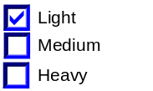 | Up/Down + OK (Select Medium or Heavy) | 0x2 (if Medium is Selected)  0x3 (if Heavy is Selected)
Medium (0x2) | 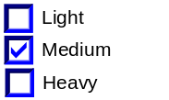 | Up/Down + OK (Select Light or Heavy) | 0x1 (if Low is Selected)  0x3 (if Heavy is Selected)
Heavy (0x3) | 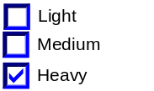 | Up/Down + OK (Select Light or Medium) | 0x1 (if Low is Selected)  0x2 (if Medium is Selected)
Error (0x0) | 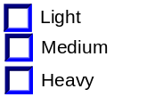 | Up/Down + OK (Select Light or Medium or Heavy) | 0x1 (if Low is Selected)  0x2 (if Medium is Selected)  0x3 (if Heavy is Selected)
Note: Trailer_Brake_Cfg must be set to Enabled (0x1) to display this menu

- This feature will be set via diagnostic at Vehicle Operations using DID DExx. Trailer_Brake_Cfg is set equal to the last value received in the diagnostic routine.
- The customer will have the ability to change the value of Trailer Brake Mode and Trailer Brake Effort when the Instrument Cluster Message Center (IC) is enabled (Operational Mode is Normal)

Function Safety Classification (EMC)

Class B

Memory Storage
Parameter Name | Description | Value at  Battery Connect | Value at  Module Wake-up
Trailer_Brake_Mode_MC | Output for TBC Mode displayed in the M/C | Error (0x2) | Do Not Init
Trailer_Brake_InitOut_MC | Output for TBC Effort displayed in the M/C | Error (0x0) | Do Not Init
TrlrBrkMde_D_Rq Signal | Output command acknowledging signal sent from the IPC to TBM for TBC Mode | Electric (0x0) | Do Not Init
TrlrBrkMde_D_Actl Signal | Input signal sent from the TBM to the IPC for TBC Mode | Electric (0x0) | Do Not Init
TrlBrkInitOut_D_Rq Signal | Output command signal sent from the IPC to TBM for initial trailer braking magnitude | Null (0x0) | Null (0x0)
TrlBrkInitOut_D_Stat Signal | Input signal sent from the TBM to the IPC for initial trailer braking magnitude | Null (0x0) | Do Not Init
M/C_Display_Status | See * below | See * below | See * below
Reset Switch Event | Event that is indicated as per the switch interface for Message Center display. See * | See * below | See * below
Operational_Mode | 4 state indicator for cluster operational mode | Limited | Limited, Normal or Crank
Trailer_Brake_Cfg | Configures cluster to allow Trailer Brake Warning Messages to be displayed, and to allow SETUP menu (set to disable at cluster end of line). See Warning – Trailer Brake Controller STSS for definition. | Use Stored Value | Use Stored Value
* Refer to Message Center X Display_Y Button Interface Section, where X and Y are appropriate values in this document.

Reconfigurable Telltale

Not Applicable

Prove Out

Not applicable

Message Center Msg

For S-HMI clusters, refer to text as defined in the Text Message List section of this SPSS.
Refer to Message Center Function description reference "B 2x14 Text Message List.xls" or "E Display 2x14 Text Message List.xls" file-- Message ID SU278 and SU920.

Error Handling

Missing Message Strategy

The signals will be declared missing as per the Diagnostics section of this SPSS.

DTCs states and history will be determined as per the Diagnostics section of this SPSS.

If Trailer_Brake_Cfg = Disabled, the cluster shall never log a missing message DTC for this feature.

Diagnostics

Self Test

None

Engineering Test Mode

Reference section “Dealer / Engineering Test Mode (ETM)”

Part II Performance
Supported Diagnostic Trouble Codes (DTCs)
DTC | Description
C13700 | Lost Communication With Trailer Brake Control Module

DID DExx
Bits | State: Description | "0" | "1" | Default | Comments/Information
1 | Trailer Brake Gain Warning | Disabled | Enabled | Disabled | If disabled, the TBM is not equipped. The TBC warnings and Setup menu are enabled together.

Reference Specification

Revision History
SPSS Module Revision History

Revision Level | Name | Change Description | Date
1.0 | SWatkins | Initial Release | 8/05/08
1.1 | SWatkins | Update typo in 1.3.5.1 (Trailer Brake Mode Control Function). The second decision box had 2 "yes" paths. | 11/20/08
1.2 | SWatkins | Per request from Bang Cao and Peter Huang, change default to Electric.  - Section 1.3.5.4 - Changed battery connect default of TrlrBrkMde_D_Rq  Notes:  Note that the cluster does not have quite the normal handshake with the TBM module. This was not intentional, but the system works as intended. This is because the TBM does not follow the usual “ignore the cluster for 2s after key in RUN so that the cluster can sync up with the correct setting” handshake. Effectively, the cluster is the “owner” of the TBM setting instead of the TBM module. Thus, the cluster has a battery connect default of Electric, which will force the setting to Electric. When the setting is changed, the cluster will store in battery backed memory. Which will then force the TBM back to the last setting each key cycle. | 5/26/2010
CGEA1.3 1.0 | V. Patel | Updated for CGEA 1.3 based on CGEA STSS v1.2  Section 1.2.2 – Removed table referencing the HS-CAN message that contains the input signal.  Section 1.2.3 – Removed table referencing the HS-CAN message that contains the output signal.  Section 1.2 – Deleted “Position” column from the input and output signal tables.  Section 1.4 – Rewritten. Deleted references of specific missing message flags and timer.  Section 1.5.3 – Deleted DTC logging criteria from the table. | 5/26/2010
CGEA 1.3/1.2/1.1 version 2.0 | T. Cwik | Feature owner John Crossman and Peter Huang and Bang Cao.  This change is to add a second Message Center Settings Menu for TBC Effort and to add the S-HMI Display interfaces.  Section 1.1 – Added text about second setting.  Section 1.2.1 – Figure 1 – Added TrlBrkInitOut_D_Stat and TrlBrkInitOut_D_Rq  Section 1.2.2 – Added Table 1.1 and renumbered subsequent tables.  Section 1.2.3 – Added Table 1.3 and renumbered subsequent tables.  Section 1.3.3.2 – Added S-HMI graphics text and example. Added SU920 to “B” or “E” display text.  Section 1.3.5.1 –  – Updated Figure 2 Trailer Brake Mode Control Function Flowchart to include the “Trailer Brake Effort” screen.  – Added Table 1.5 and renumbered subsequent tables.  Section 1.3.5.2 –  – Added Tables 1.7, 1.8 and 1.9  – Added “and Trailer Brake Effort” to 2nd tic point  Section 1.3.5.4 – Added Trailer_Brake_InitOut_MC, TrlBrkInitOut_D_Stat and TrlBrkInitOut_D_Rq  Section 1.3.5.7 – Added S-HMI text. Added SU920 to “B” or “E” display text. | 12/12/2012
CGEA 1.3/1.2/1.1 version 2.1 | S. Watkins  M. Hakim | This revision is to handle open issues, as well as spec cleanup. Details are as follows:  Updated Configuration DID DE00 to DExx throughout the document.  Section 1.2.2: Corrected configuration typo Trailer_Brake_Cfg instead of TBC_Cfg  Corrected CAN input signal TrlrBrkMde_D_Actl & CAN output signal TrlrBrkMde_D_Rq detail values throughout the document.  Removed SU Message IDs throughout the document.  Section 1.3.5.4, Memory Storage table: Updated TrlrBrkMde_D_Actl Signal initialization at Battery Connect.  Updated document footer. | 9/24/2013

